**Task 4: SQL for Data Analysis**

**Objective: Use SQL queries to extract and analyze data from a database.**

**Tool: MySQL**

**Basic Quires**

Show tables;

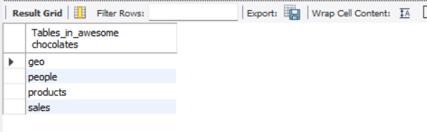

Desc sales;

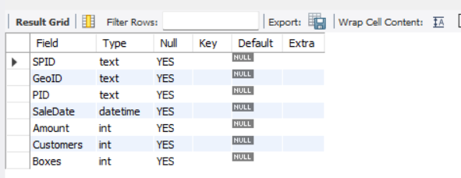

select * from sales;

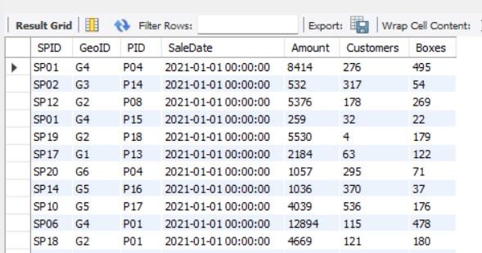

select SaleDate, Amount, Customers from sales;

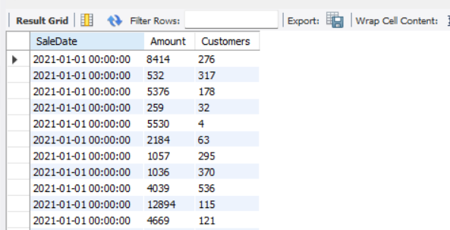

**Calculations in Quries**

select SaleDate, Amount, Boxes, Amount/boxes as 'Amt per Box' from sales;

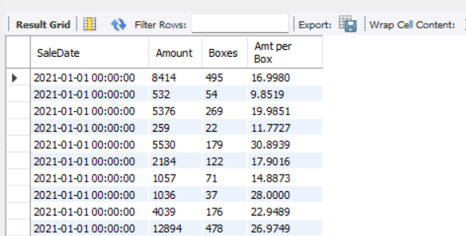

select * from sales where Amount > 10000;

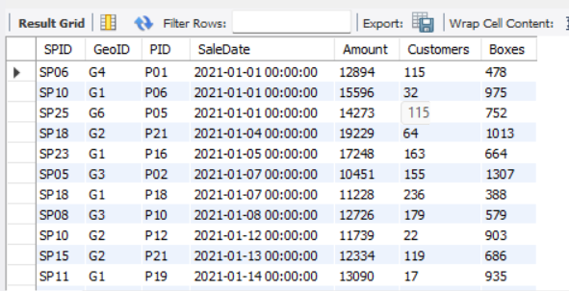

**ORDER By in SQL**

select * from sales where Amount > 10000 order by Amount desc;

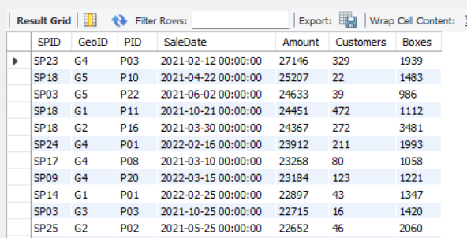

select * from sales where GeoID ='g1' order by PID, Amount asc;

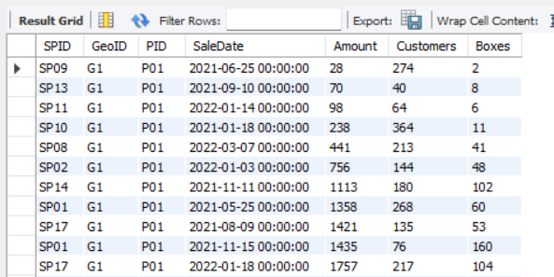

**Where clause**

select * from sales where Amount > 10000 and SaleDate >= '2020-01-01' ;

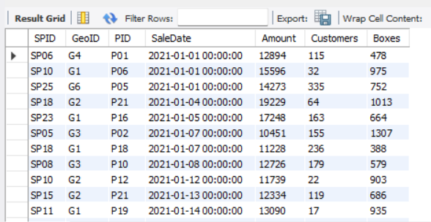

select SaleDate, Amount from sales where Amount > 10000 and year(SaleDate) = 2022 order by Amount desc;

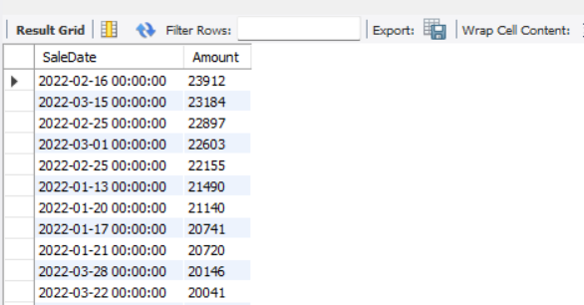

**Between Condition**

select * from sales where boxes > 0 and boxes <=50 order by boxes asc;

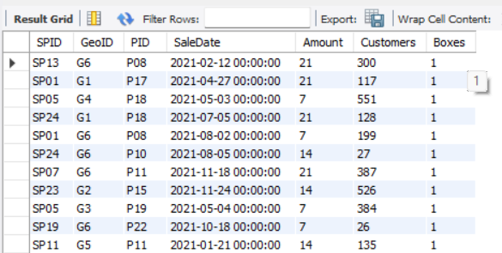

select * from sales where boxes between 0 and 50 ;

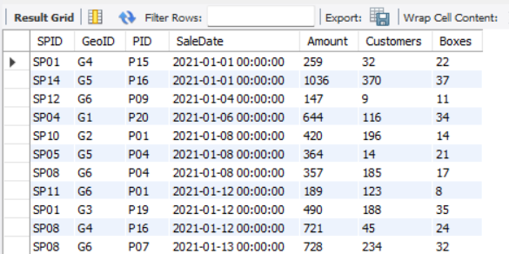

**Working with Dates**

select SaleDate, Amount, Boxes, weekday(SaleDate) as 'Day of week'

from sales where weekday(SaleDate)=4 ;

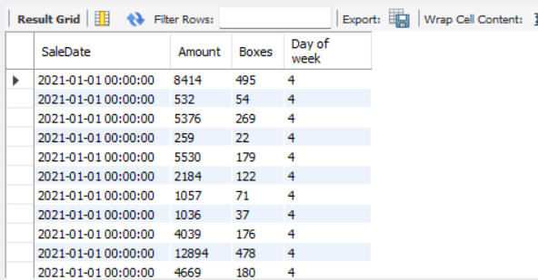

**Using Multiple Tables**

select * from people where team ='Delish' or team='Yummies';

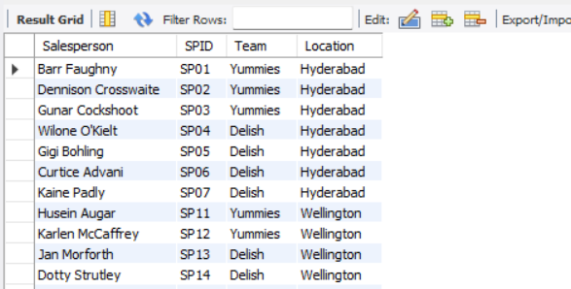

select * from people where team in ('Delish', 'jucies');

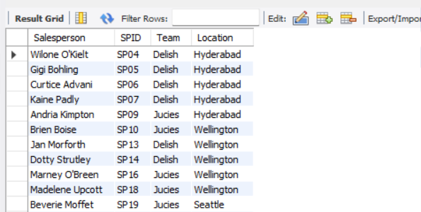

**Pattern Matching**

select * from people where Salesperson like 'B%';

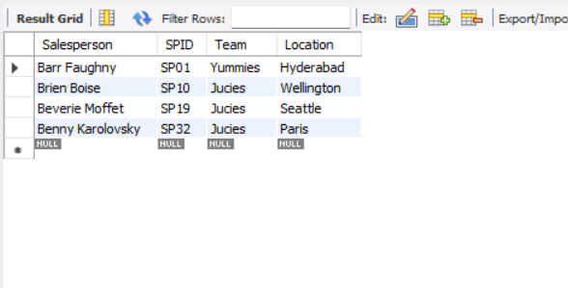

select * from people where Salesperson like '%B%';

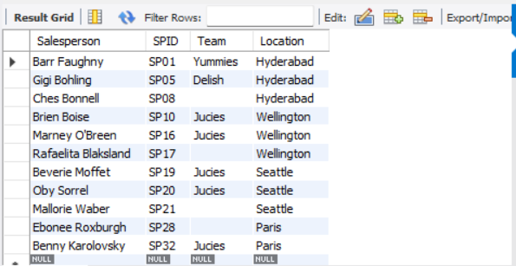

select * from people where Salesperson like '%t';

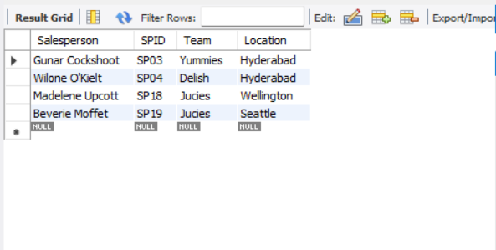

**CASE Operator**

select * from sales;

select SaleDate, Amount,

case when amount < 1000 then 'Under 1k'

when amount < 5000 then 'Under 5k'

when amount < 10000 then 'Under 10k'

else '10k or More'

end as 'Amount Category'

from sales;

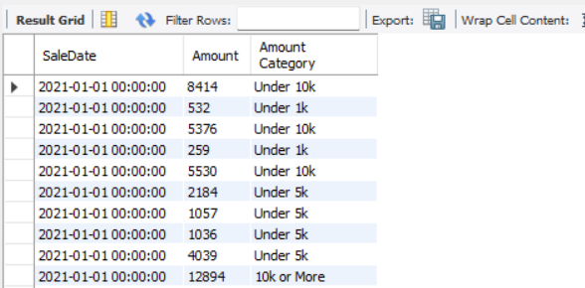

**Joins**

select s.SaleDate, s.amount, p.Salesperson, s.SPID, p.SPID

from sales s

join people p on p.SPID = s.SPID;

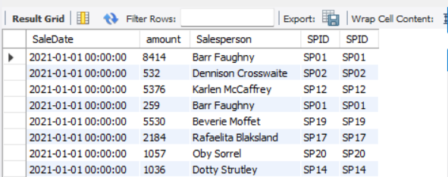

select s.SaleDate, s.Amount, s.PID, pr.product

from sales s

left join products pr on pr.pid = s.pid;

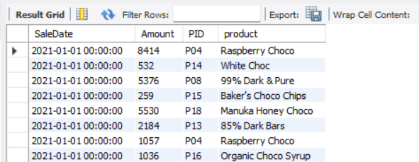

select s.SaleDate, s.Amount, p.Salesperson, pr.Product, p.Team

from sales s

join people p on p.SPID = s.SPID

join products pr on pr.pid = s.pid;

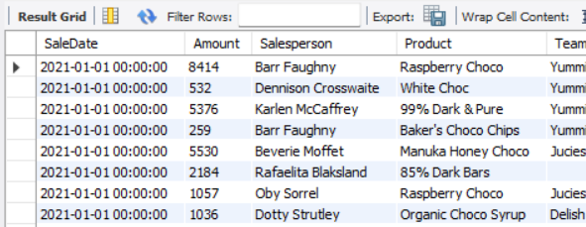

**Conditions with joins**

select s.SaleDate, s.Amount, p.Salesperson, pr.Product, p.Team

from sales s

join people p on p.SPID = s.SPID

join products pr on pr.pid = s.pid

where s.amount < 100;

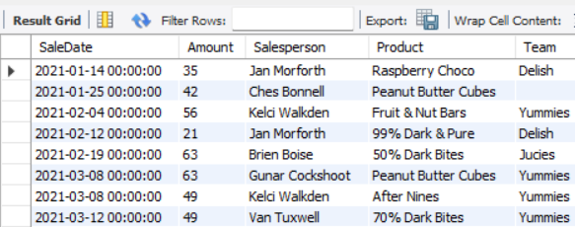

select s.SaleDate, s.Amount, p.Salesperson, pr.Product, p.Team

from sales s

join people p on p.SPID = s.SPID

join products pr on pr.pid = s.pid

where s.amount < 500

and p.Team = 'Delish';

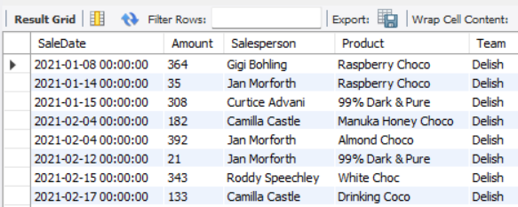

select s.SaleDate, s.Amount, p.Salesperson, pr.Product, p.Team

from sales s

join people p on p.SPID = s.SPID

join products pr on pr.pid = s.pid

where s.amount < 500

and p.Team = '';

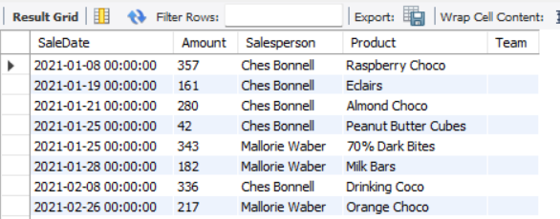

select s.SaleDate, s.Amount, p.Salesperson, pr.Product, p.Team

from sales s

join people p on p.SPID = s.SPID

join products pr on pr.pid = s.pid

join geo g on g.geoid = s.geoid

where s.amount < 500

and p.Team = ''

and g.Geo in ('New Zealand','India')

order by saleDate ;

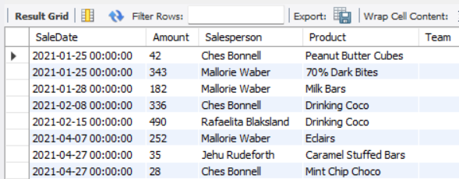

**Group By and aggregate functions**

select geoID, sum(amount) from sales group by geoID;

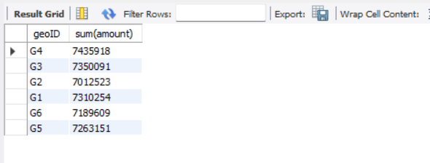

select geoID, avg(amount) from sales group by geoID;

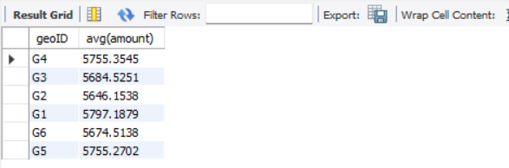

select geoID, sum(amount), avg(amount), sum(boxes)

from sales

group by geoID;

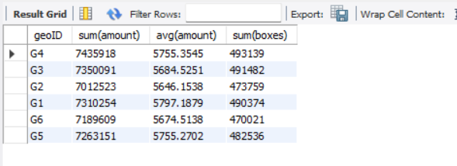

select g.geo, sum(amount), avg(amount), sum(boxes)

from sales s

join geo g on s.GeoID = g.geoID

group by g.geo;

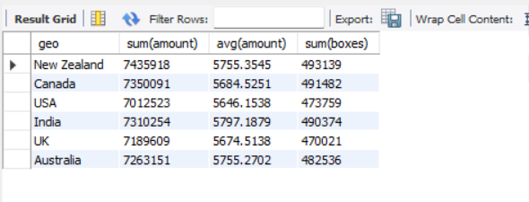

select pr.category, p.team, sum(boxes), sum(amount)

from sales s

join people p on p.spid = s.spid

join products pr on pr.pid = s.pid

group by pr.category, p.team

order by pr.category, p.team;

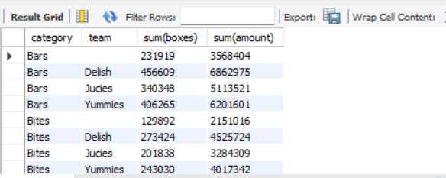

select pr.Product, sum(s.amount) as 'Total Amount'

from sales s

join products pr on pr.pid = s.pid

group by pr.Product

order by 'Total Amount' desc

limit 5;

